First and Last Name: _________________________________
UIL Coach or 3rd Period Teacher: ____________________
DUE: December 8th to D103

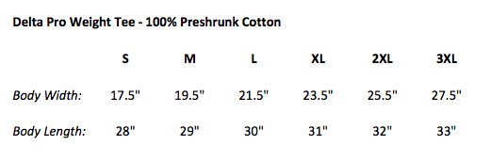

ADULT SM _____ QTY @ $15.00 ea = __________
ADULT MED _____ QTY @ $15.00 ea = __________
ADULT LG _____ QTY @ $15.00 ea = __________
ADULT XLG _____ QTY @ $15.00 ea = __________
ADULT 2XL _____ QTY @ $15.00 ea = __________
ADULT 3XL _____ QTY @ $15.00 ea = __________

****DUE BY DEC. 8th**** to Coach Walker in ROOM D103 or to your UIL Academic Coach
$15 Cash or Checks made payable to Tasha Mayfield
CASH ______________ CHECK _____________
TOTAL $____________

